**USB camera test tutorial**

Input lsusb or ls /dev/video* command to view camera service

As shown below.

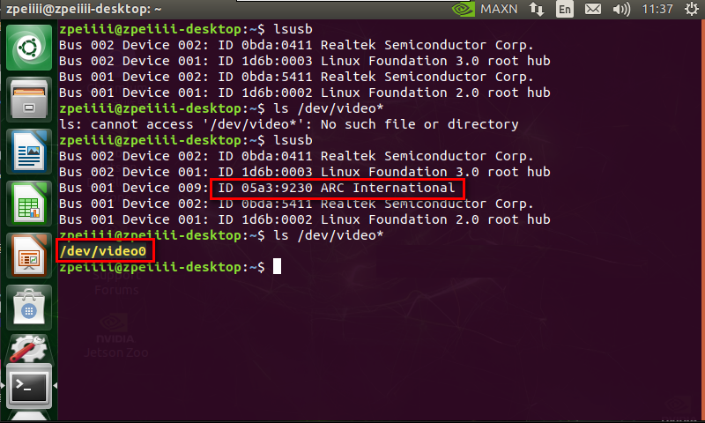

**Test camera:**

1. Using application camorama

Input following command

sudo apt-get install camorama

After installation is complete, input following command.

camorama

The video information is displayed.

1. Using application cheese

Input following command

sudo apt-get install cheese

After installation is complete, input following command.

cheese

The video information is displayed.